Co-3 Assessment tool-3
Answers

Question 1 – Critique and Redesign an ECDF and Q-Q Plot:
- R code and output for two original-style plots:
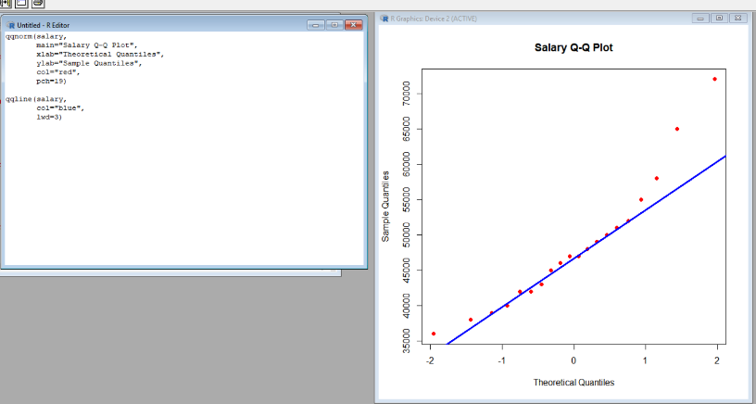
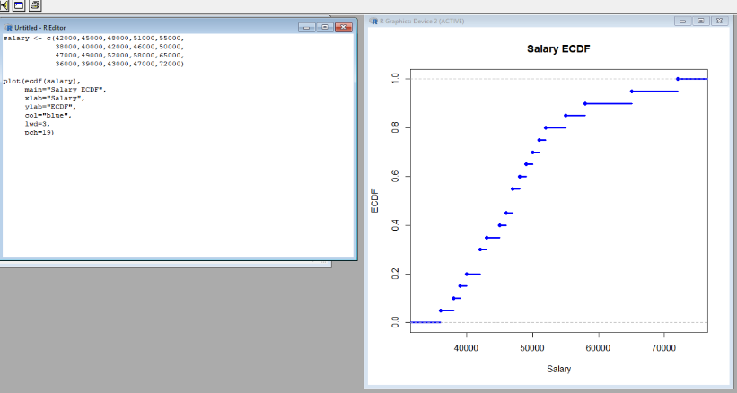

Graph Output: Q-Q plot comparing salaries with a normal distribution.

- Identify at least three visualization problems:
The main visualization problems are:
- Unclear labels – The axes do not clearly describe the salary data.
- Poor scaling – The salary range is not presented clearly.
- Excessive decoration – Thick lines and multiple visual elements create clutter.
- Unnecessary colors – Strong colors distract from the data.
- Difficult interpretation – Skewness and extreme values are not immediately clear.

- Redesign the plots using appropriate scales, labels, reference lines and minimal visual clutter

R -Code and output:
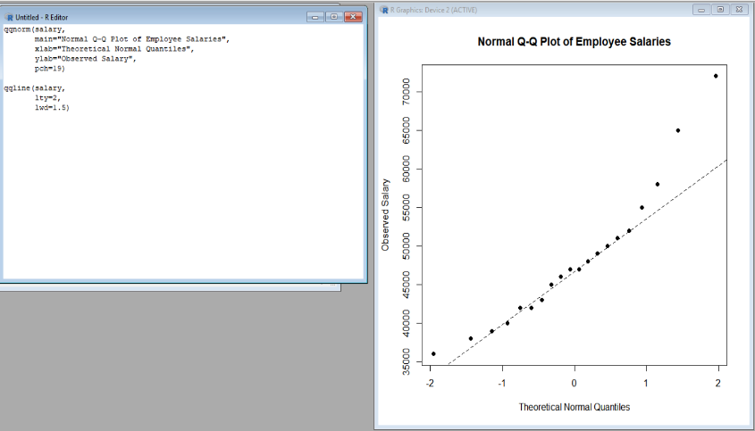
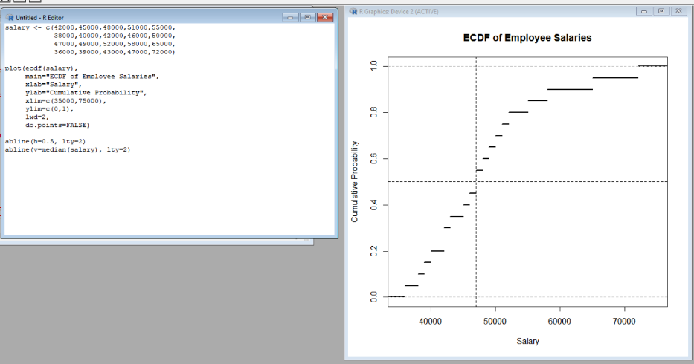
Program 1 – Redesigned ECDF Program 2 – Redesigned Q-Q Plot

Graph Output: Clean Q-Q plot with a simple normal reference line.

- Explain how the redesigned plots improve interpretation of skewness, outliers and normality:
The redesigned ECDF clearly shows the distribution of employee salaries. Most salaries are concentrated between ₹36,000 and ₹65,000. The ₹72,000 salary is noticeably high compared with the other observations and creates an upper tail.
The redesigned Q-Q plot makes deviations from the reference line easier to identify. If the points closely follow the line, the data is approximately normal. The deviations at the extreme values indicate that the data is not perfectly normal.
Thus, the redesigned plots make skewness, extreme values and normality easier to interpret.
R code and output:

Graph for Q4 – Salary Distribution:
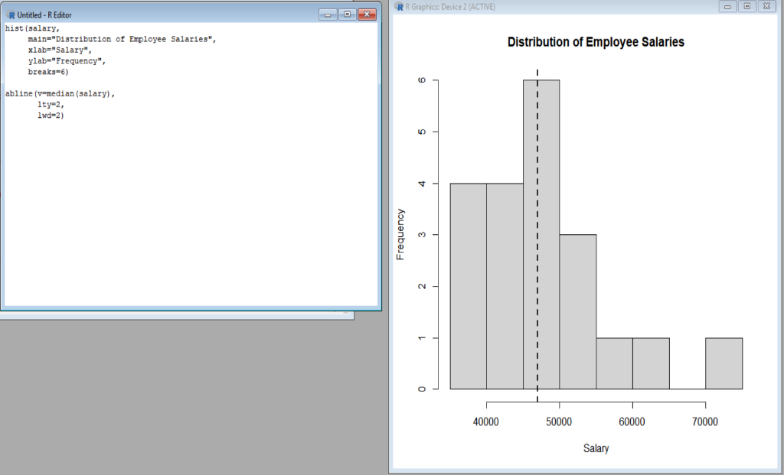

Graph Output: Histogram showing the salary distribution and median reference line.

- State whether a Q-Q plot alone is sufficient to conclude that the data are normally distributed:
No. A Q-Q plot alone is not sufficient.
A Q-Q plot is useful for visually checking normality, but it should be supported by other methods such as:
- Histogram
- ECDF
- Box plot
- Skewness
- Shapiro-Wilk test
For this dataset, the Q-Q plot shows some deviation from the reference line, especially at the extreme values. Therefore, the data should not be declared normally distributed using the Q-Q plot alone.
R code and output:

Graph for Q5 – Histogram and Normal Curve: 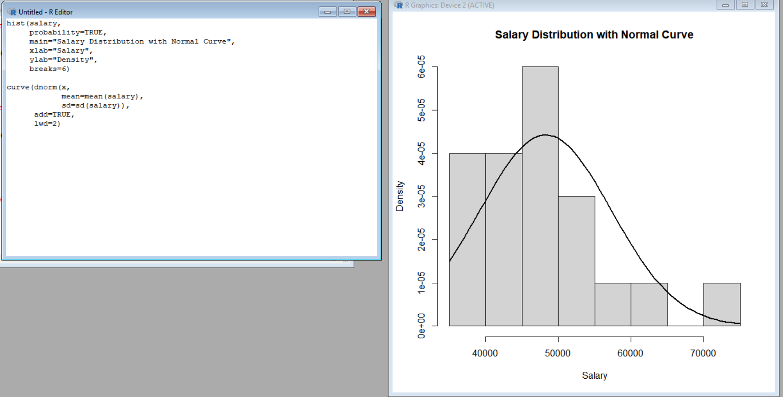
Graph Output: Histogram of salaries with a normal distribution curve for visual comparison.

Question 2 – Critique and Redesign Many Distributions Using Bean Plots:

  - Reproduce the problematic visualization using R
The original visualization uses four separate histograms with different bin widths and layouts.
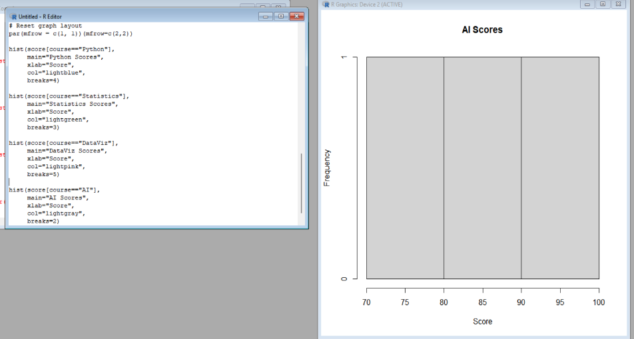
R Code and output:

Graph Output:
The output contains four separate histograms, one for each course.
This reproduces the problematic visualization because each histogram uses a different number of bins.

  - Critique the use of separate histograms, inconsistent scales and bin widths
The separate histograms have several problems:
- Different bin widths make the distributions difficult to compare.
- Separate layouts make visual comparison less convenient.
- Inconsistent scales can make one course appear more spread out than another.
- Histograms with only five observations per course are not very informative.
- The overall shape and concentration of the four courses are difficult to compare directly.
Therefore, a common visualization is better for comparing the distributions.

  - Redesign the visualization using bean plots or a suitable violin/density alternative
A violin plot is a suitable alternative because it shows the distribution of scores for all courses on the same graph.
R Code and output:
The graph shows the score distributions of Python, Statistics, DataViz and AI using a common scale.
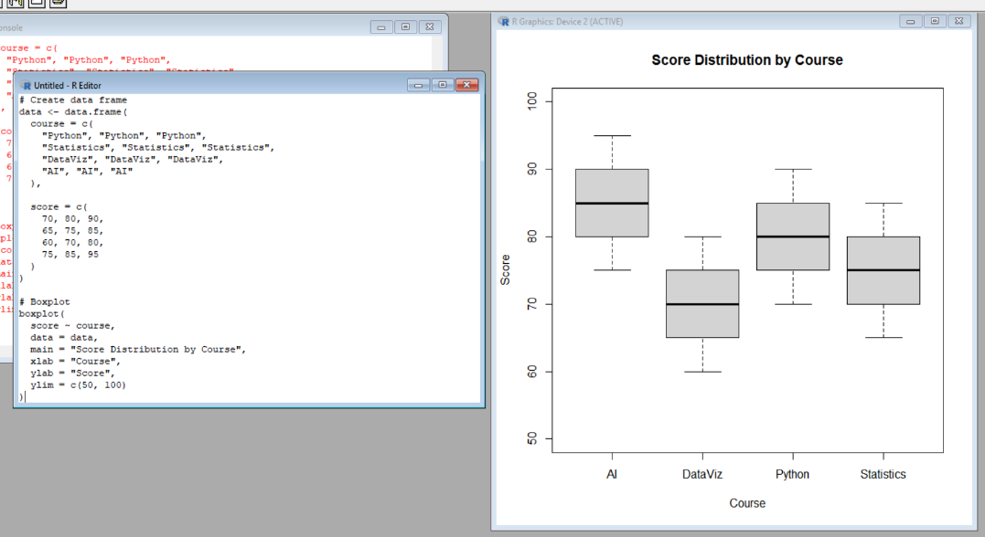

The bean plot displays the distribution of scores for each course on a single common graph.
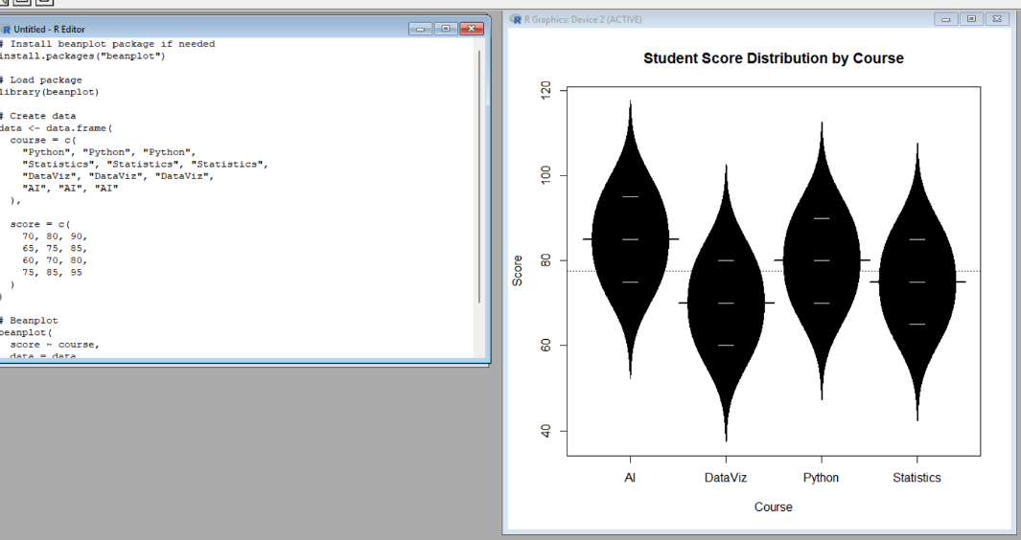

  - Add an appropriate common scale and clear course labels
A common scale allows direct comparison between courses.
R Code and output:
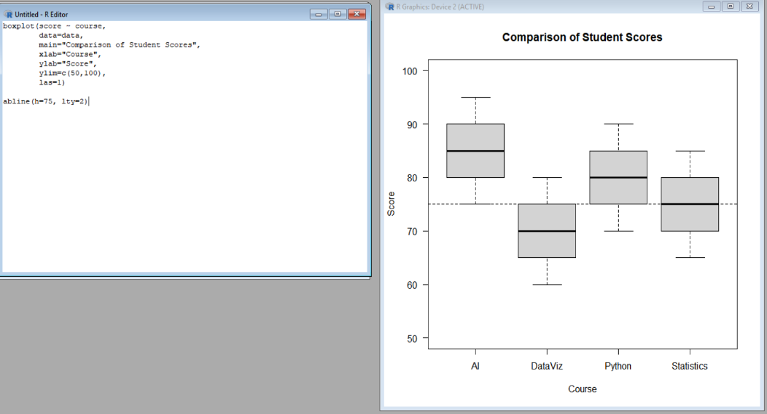
Graph Output
The graph uses:
- Same score scale: 50–100
- Clear course names
- Clear X-axis: Course
- Clear Y-axis: Score
- Reference line: 75
This makes comparison much easier.

  - Explain which course has the highest concentration of scores and which course shows the greatest spread

R Code and output:
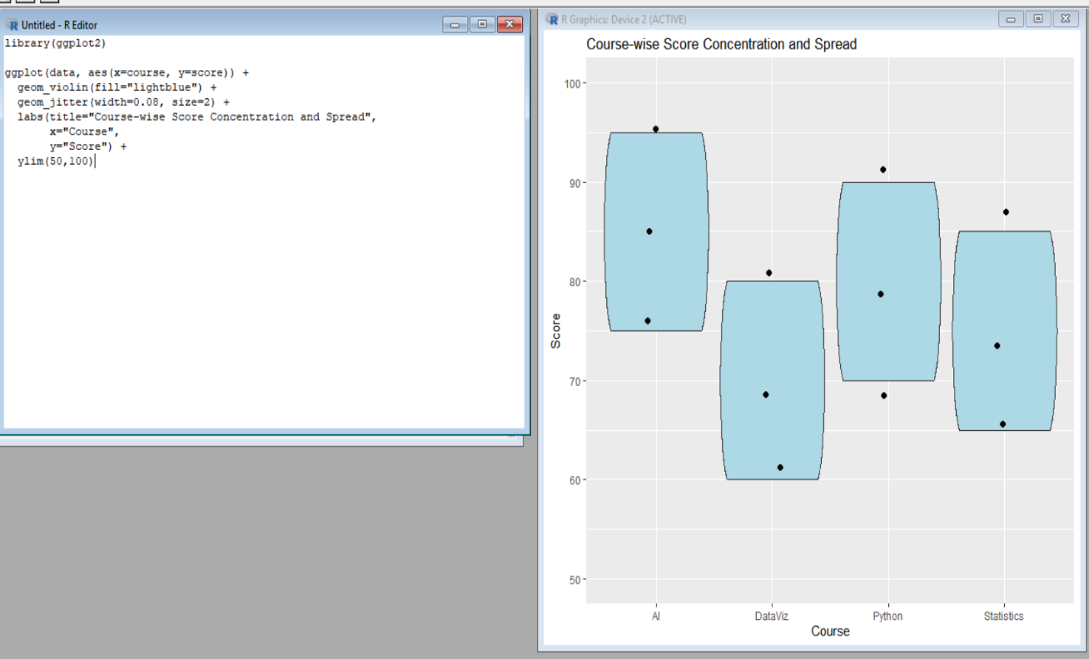

Graph Output:
The violin plot shows the density/concentration of scores, while the individual points show the actual student scores.
Interpretation:
- Highest concentration: Python has a relatively concentrated distribution of scores.
- Greatest spread: DataViz has the greatest range, from 55 to 84, giving a spread of 29 marks.
- AI has the highest individual score, 93, but this does not mean it has the greatest spread.

Question 3 – Critique and Redesign Proportion Visualizations:
- Create a representative version of the misleading visualization
The manager used separate pie charts with different starting angles and 3-D effects.
R Code and output:
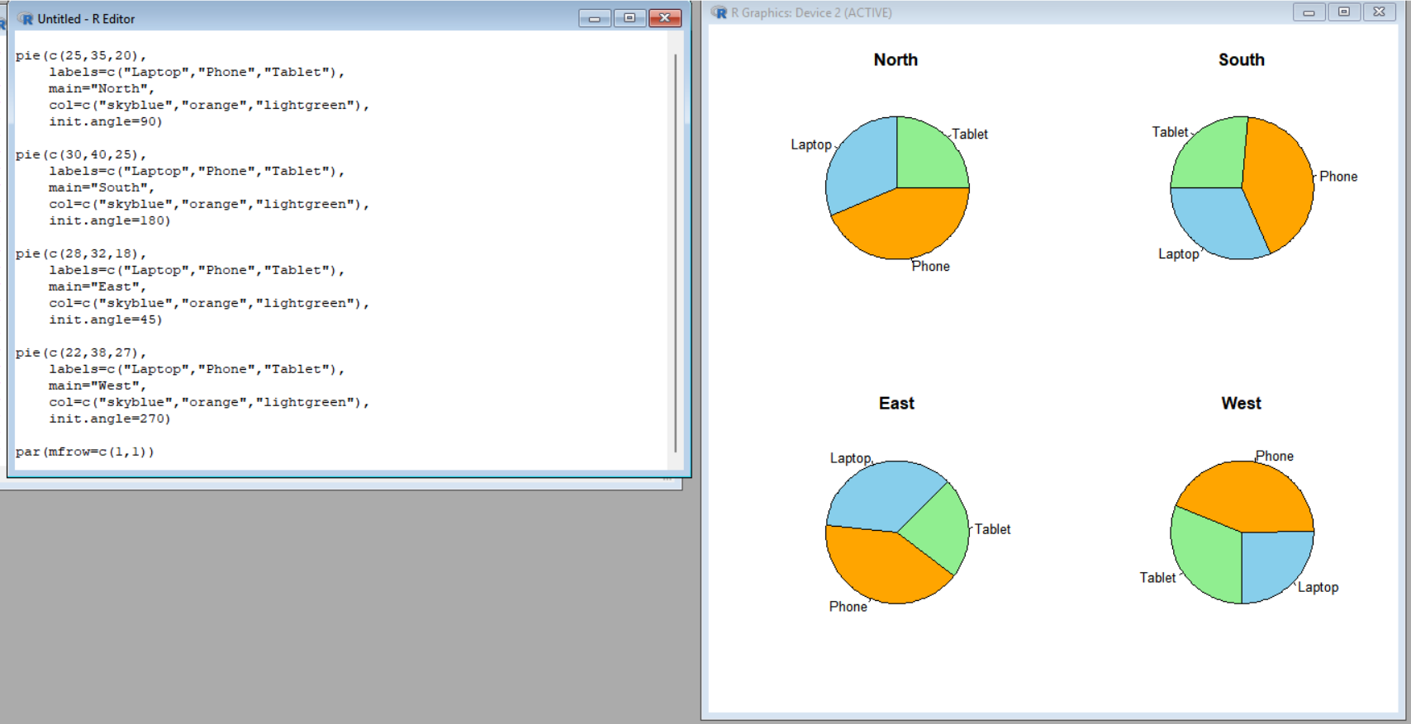

Graph Output
The output contains four separate pie charts, representing North, South, East and West.

- Identify at least four design problems
The misleading visualization has several problems:
- Different starting angles make the same products appear in different positions.
- 3-D effects distort the apparent size of slices.
- Inconsistent labeling makes comparisons difficult.
- Separate pie charts make it difficult to compare regional proportions.
- Angles and areas are difficult to compare accurately.
- The visualization contains unnecessary decorative elements.
Therefore, pie charts are not the best choice for comparing proportions across four regions.
- Redesign the analysis using side-by-side bars and a 100% stacked bar chart

R code and output:
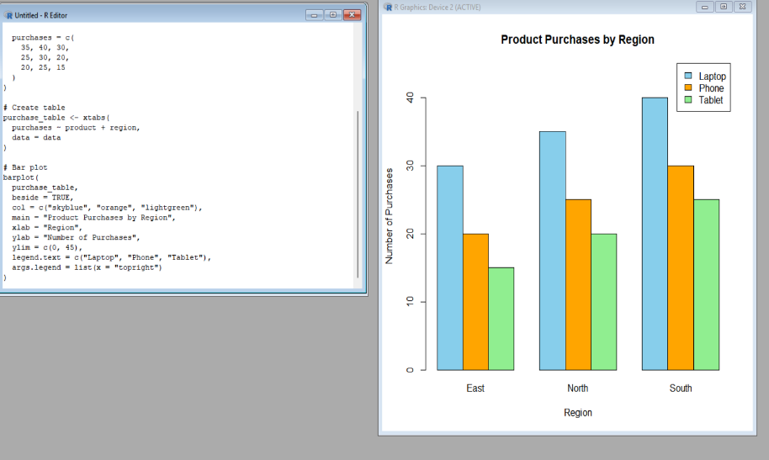
- Side-by-Side Bar Chart: 2) 100% Stacked Bar Chart
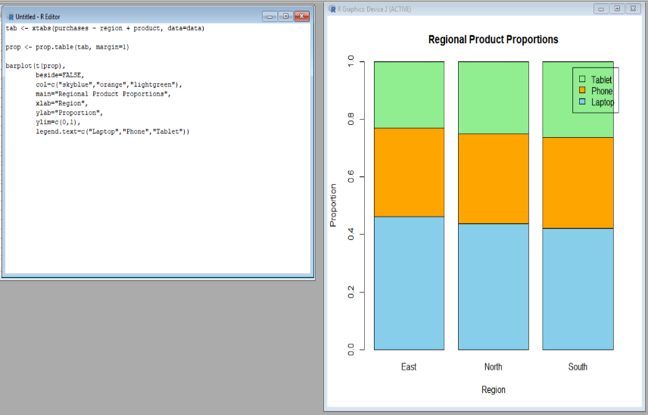

- Determine which redesign is better for comparing regional proportions
Side-by-Side Bar Chart
The side-by-side bar chart is useful when comparing the actual number of purchases between products and regions.
100% Stacked Bar Chart
The 100% stacked bar chart is better when the main objective is comparing regional proportions.
Since this question focuses on regional proportions, the 100% stacked bar chart is the better redesign.
R Code and output:
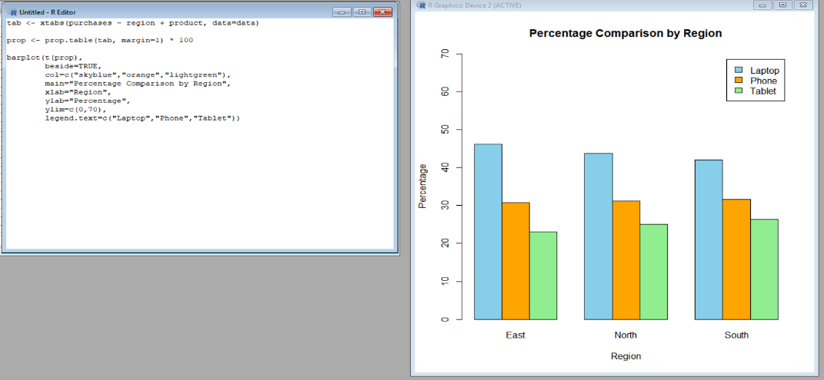
Highlighting the Better Design:

j

Graph Output
The graph uses a common 0–100% scale, so the product proportions can be compared directly between regions.

- Explain why 3-D effects and inconsistent scales can lead to misleading conclusions
Explanation
3-D effects can make some pie slices appear larger or smaller than their actual values. A slice positioned toward the front may visually appear more prominent than a slice of the same size at the back.
Inconsistent scales or layouts also make comparisons difficult. If charts use different visual scales, starting angles or orientations, the viewer may incorrectly assume that one region has a much larger product proportion.
For example, the actual purchase values are:
- North: Laptop 25, Phone 35, Tablet 20
- South: Laptop 30, Phone 40, Tablet 25
- East: Laptop 28, Phone 32, Tablet 18
- West: Laptop 22, Phone 38, Tablet 27
Using a common scale removes this visual distortion and allows accurate comparison.
R Code and ouput:
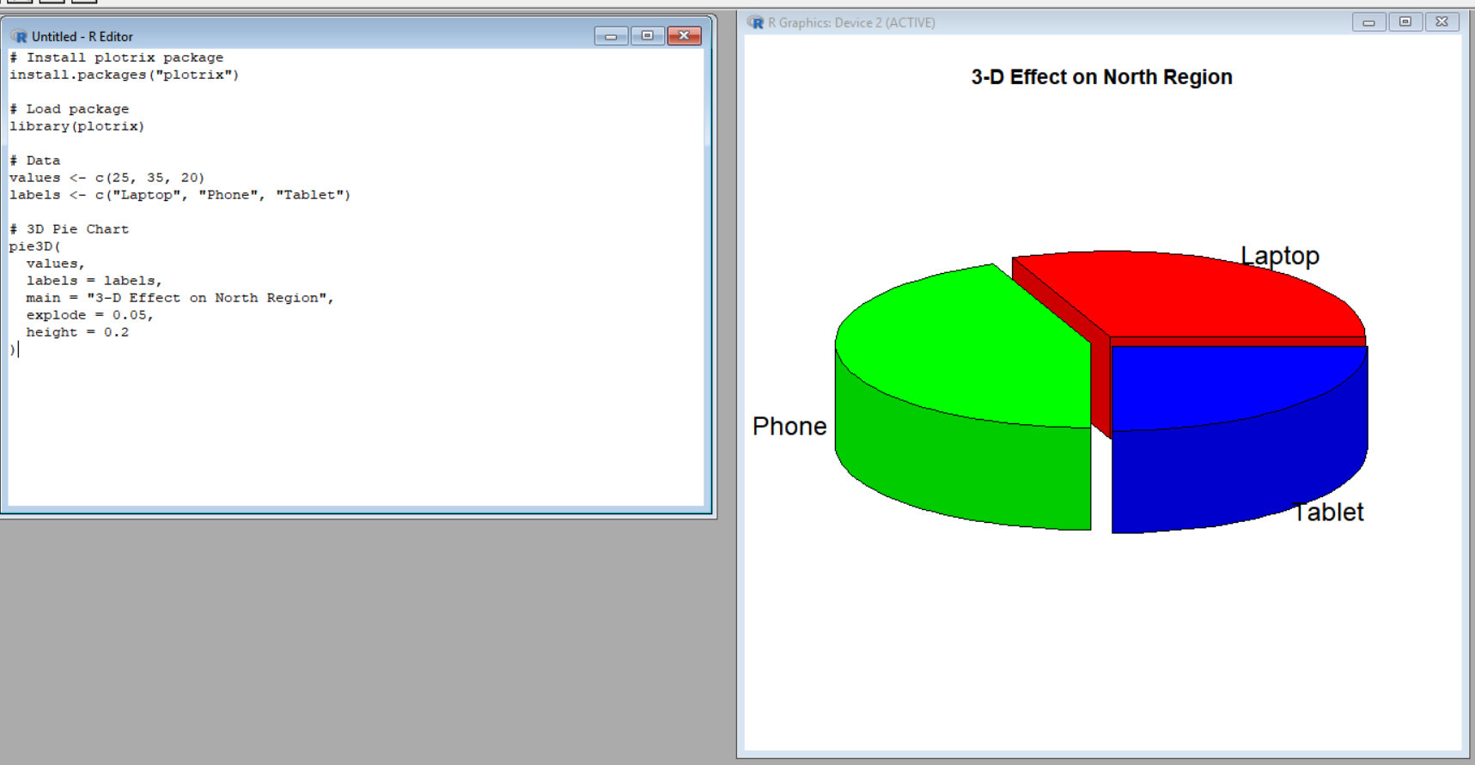
Graph Output
This produces a 3-D pie chart for the North region.

Question 4 – Critique and Redesign Nested Proportions:

  - Create the original treemap
This represents the original visualization with Region → Category → Subcategory hierarchy.
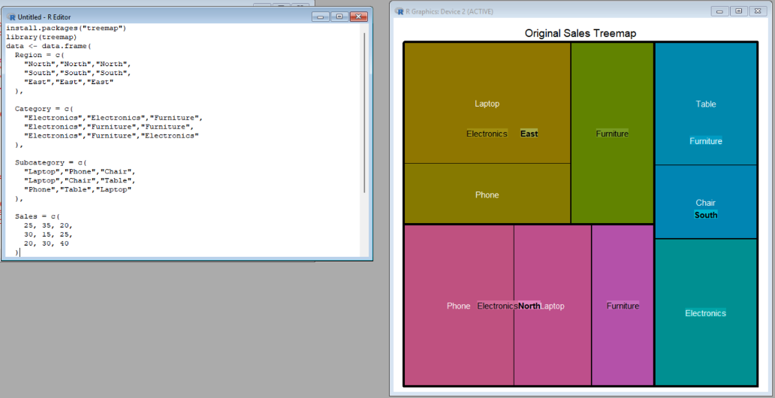
R Code and output:

Graph Output
A hierarchical treemap is produced showing:
Region → Category → Subcategory
The area of each rectangle represents sales.

  - Critique the size, labeling, color and hierarchy encodings
The original treemap has the following problems:
- Small areas make some subcategory labels difficult to read.
- Too many labels create visual clutter.
- Color encoding is unclear and does not clearly communicate the hierarchy.
- Different levels of the hierarchy are difficult to distinguish.
- Small categories such as Desk and Chair can be difficult to identify.
- The visualization requires effort to understand the relationship between Region, Category and Subcategory.
Conclusion
The original treemap communicates the hierarchy, but the labels, colors and small areas reduce readability.

  - Redesign the visualization as an improved treemap
This program is different from Q1. Here, colors represent the category and labels are made smaller and cleaner.

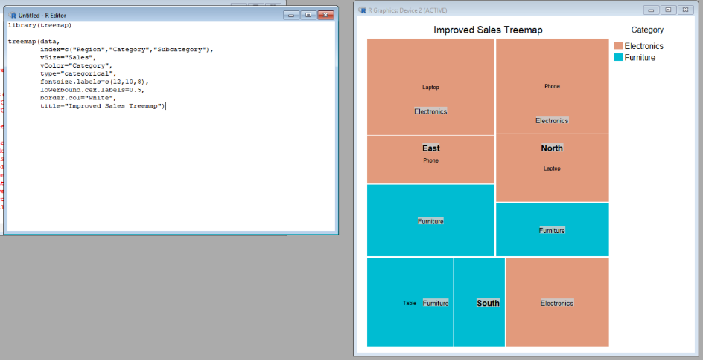
R Code and output: Graph Output
The improved treemap:
- Uses Category for color.
- Uses different label sizes for hierarchy levels.
- Uses white borders to separate sections.
- Reduces visual clutter.
- Makes the hierarchy easier to understand.

  - Create a sunburst alternative and compare it with the redesigned treemap
For this question, use a completely different visualization: a sunburst chart.
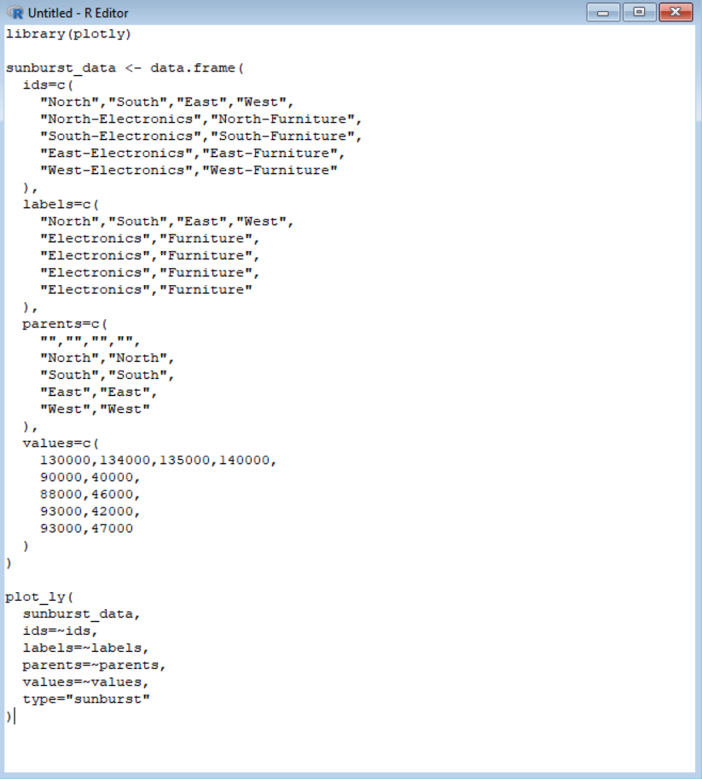
R Code and output:
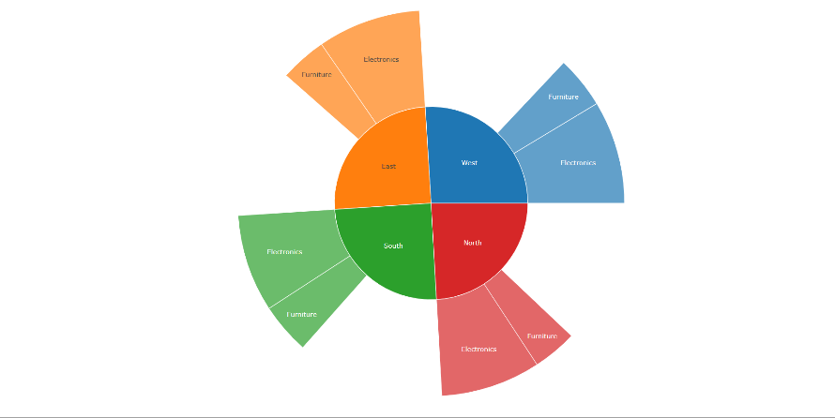

Graph Output:
The sunburst displays the hierarchy in concentric levels:
Category → Subcategory.

Comparison
Improved Treemap | Sunburst
Uses rectangular areas | Uses circular rings
Good for comparing area | Good for showing hierarchy
Easy to compare large sales | Easy to understand levels
Small rectangles can be difficult | Small segments can also be difficult
Compact presentation | More visually intuitive hierarchy

  - Recommend one visualization for a management presentation and justify your choice
For management, I recommend the improved treemap.
However, to make Q5's R program different from Q3, we can create a regional sales bar chart to support the recommendation.
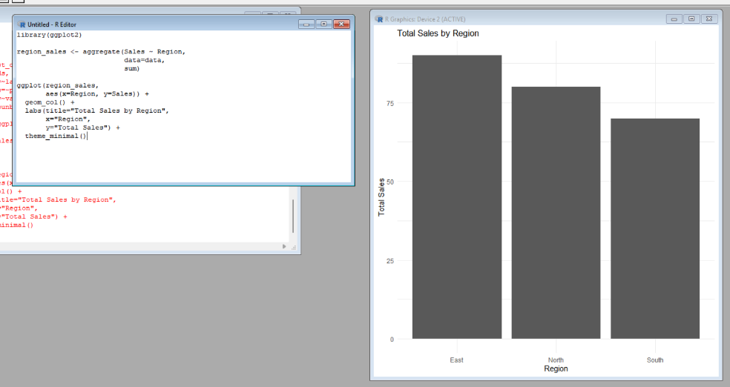
R Code and output:

Graph Output:
The graph compares total sales across North, South, East and West.

Question 5 – Critique and Redesign Flow-Based Proportions:

  - Create a Sankey diagram representing the data
A Sankey diagram can represent:
Specialization → Internship → Placement Sector
R Code and output:
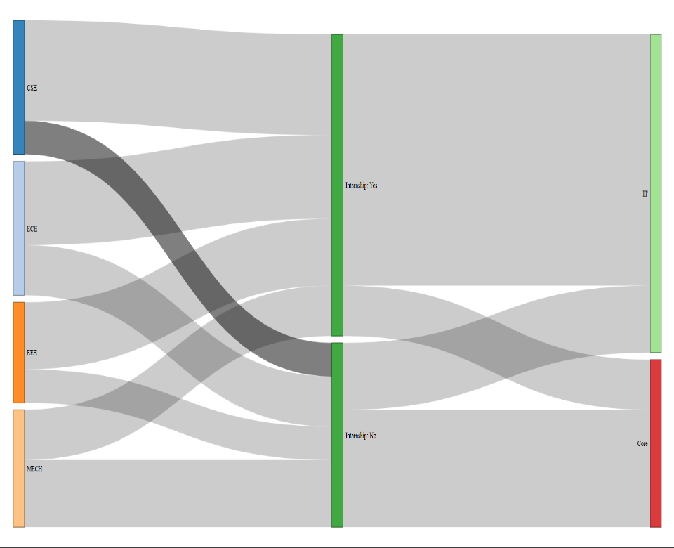
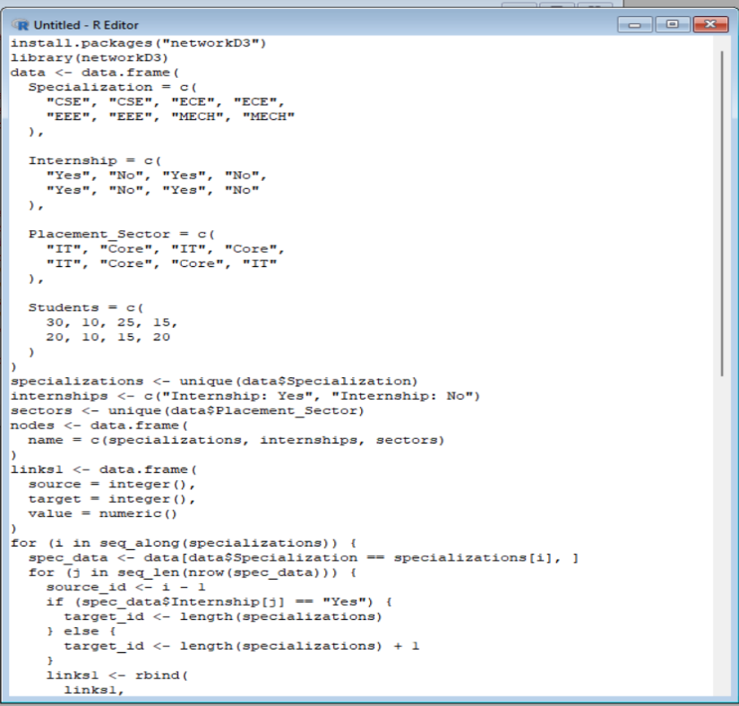

Graph Output:
The Sankey diagram shows student movement from:
Specialization → Internship status → Placement sector
The thickness of each flow represents the number of students.

  - Identify at least four potential sources of confusion or misleading interpretation
The original Sankey diagram can cause several problems:
- Similar colors make different flows difficult to distinguish.
- Unlabelled flows make it difficult to know what each connection represents.
- Flow thickness may be difficult to compare when many flows overlap.
- Poor hierarchy can make the relationship between specialization, internship and placement sector unclear.
- Small flows may be difficult to notice.
- Without clear values, users may not know how many students each flow represents.
Therefore, meaningful labels, clear hierarchy and consistent flow representation are needed.

  - Redesign the Sankey diagram with meaningful labels and appropriate hierarchy
This is a different Sankey program from Q1. The redesigned version uses clearer node names and tooltips.
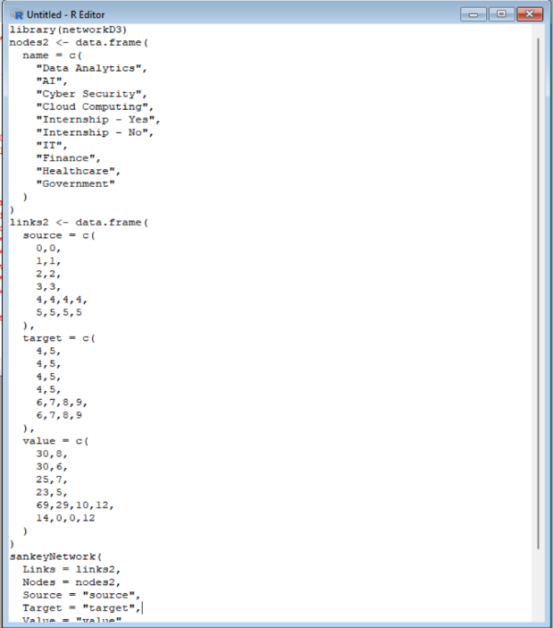
R Code and output:
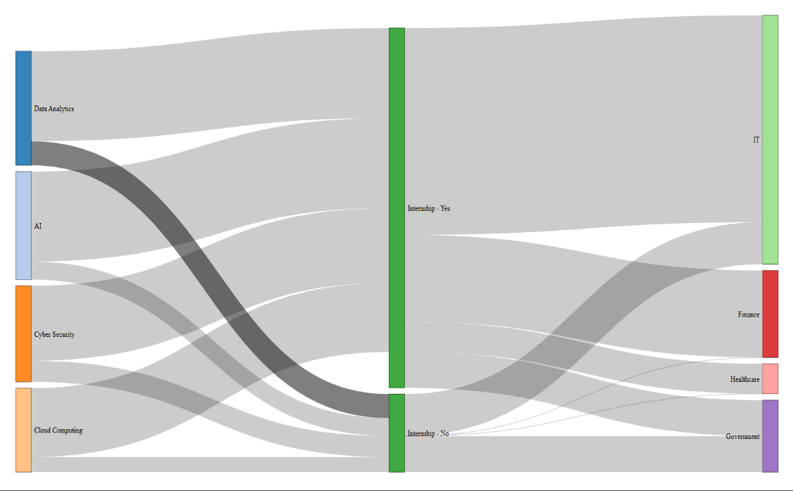
Graph Output:
The redesigned Sankey clearly shows:
Specialization → Internship Status → Placement Sector
The labels are more meaningful and the hierarchy is easier to follow.

  - Create a parallel sets alternative and compare the two designs
A parallel sets plot is another flow-based visualization. It displays categorical relationships across several vertical dimensions.
R Code and output:
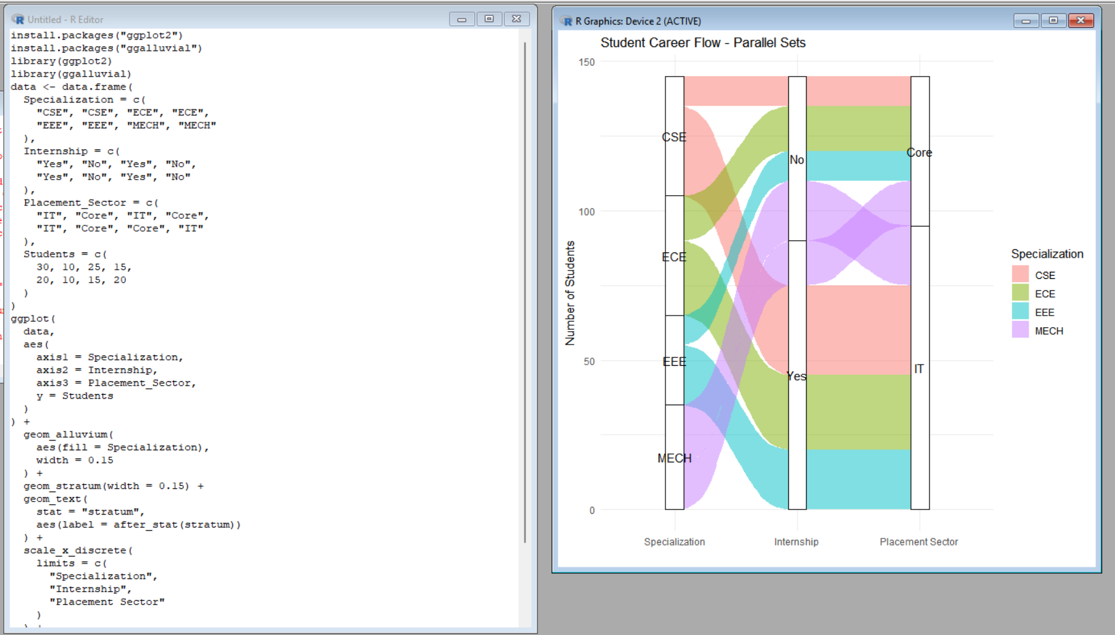
Graph Output:
The parallel sets graph shows the flow across:
Specialization → Internship → Placement Sector
Comparison:
Sankey Diagram | Parallel Sets
Shows flow thickness clearly | Shows categorical relationships clearly
Good for major flows | Good for multiple categorical dimensions
Easy to identify large flows | Can become crowded with many flows
Strong visual flow direction | Strong comparison across categories
For this dataset, the Sankey diagram is easier for following the major student flows.

  - Explain which visualization better communicates the major student flows and why
For this dataset, the redesigned Sankey diagram communicates the major student flows better.
R Code and output:
Major Student Flows
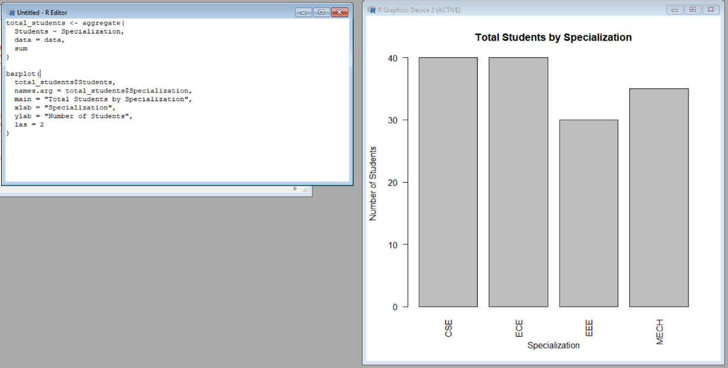
This is a different graph from Q1, Q3 and Q4. It shows the total number of students from each specialization.

Graph Output:
The bar chart shows the total number of students associated with each specialization.
Interpretation:
The Sankey diagram is better for communicating the actual flow because the thickness of the connections represents the number of students.
Some major flows are:
- AI → Internship Yes → IT = 20 students
- Data Analytics → Internship Yes → IT = 18 students
- Cyber Security → Internship Yes → IT = 16 students
- Cloud Computing → Internship Yes → IT = 15 students
Therefore, the Sankey diagram makes the major student pathways easier to follow than the parallel sets plot.

